**IT2120 - Probability and Statistics – Lab Sheet 09**

**Exercise**

01)

i)

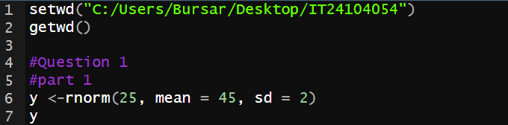

ii)

